**Automated Parking Garage System**

**Submitted to: Dr. Rasha Montasser**

**Eng. Noha Sobhy and Eng. Jumana Ahmed**

**Table of Contents:**

1. **Project Description**
2. **Software Requirements**
   1. **Functional Requirements**
   2. **Non-Functional Requirements**
3. **Use-Case Diagram**
4. **Usage-Scenarios**
5. **Class Diagram**
6. **Sequence Diagrams**
7. **State Chart**
8. **Activity Diagram**
9. **ERD**

**10. Data Flow Diagram**

**10.1 Level 0**

**10.2 Level 1**

**10.3 Level 2**

**11. Package Diagram**

**12. Deployment Diagram**

1. **Project Description:**

The purpose of this project is to track and manage the occupancy of a parking garage and allow customers to find and reserve available parking places.

The parking garage will be remodeled so that the parking decks above the ground level will be accessible only using an elevator that will lift the vehicles to different decks. All vehicles will depart the garage by descending down the designated exit pathway to the ground level. The ground level will be reserved for walk-in customers. All other levels will be reserved for registered customers that made advance reservations. Only passenger vehicles can be parked in this parking garage. That is large trucks, buses, etc., cannot enter this parking garage.

**Garage Access Control:** The garage will have installed two license-plate readers: one at the lift platform and the other at the end of the exit pathway. The reader will use a digital camera and a license-plate recognition system. When a vehicle drives up onto the lift platform, the license-plate reader will read the vehicle reservation number. The other reader will record the reservation number of the departing vehicles.

**Occupancy Monitoring:** Every parking spot has installed a sensor that senses the occupancy of the spot by a vehicle. There will be a digital display installed on the ground floor that will indicate available vacancies for walk-in customers without reservations. This display will also indicate if the ground-level parking area is full.

There will be a digital display installed in the vehicle elevator to display various messages. Other messages will include information for registered customers without advance reservation or denied access to upper decks, or information for registered customers about changes in their reservation.

**The Registration Software:** Customers will register at the company website in advance of using the parking garage. At registration time, the customer will provide demographic information and a valid email, and his or her credit card number. The customer may provide the license plate numbers for his or her vehicle(s), but this is not required to allow registration of customers who do not own vehicles but will use a borrowed or rented vehicle. The license plate numbers are required when reserving an empty spot in the garage. Reservation for an empty spot can be done when the registered customer arrives at the garage. It may also support guaranteed reservations, which allow customers to make a (monthly) contract with the parking garage for a parking spot. Such customers are desirable because they can provide predictable and steady income. A registered customer may edit/cancel their reservation an hour before their reservation time to avoid any penalty charges.

**Administration:** The manager will be able to login into the system to view monthly reports, and payroll information, and change prices for the parking garage. The manager will also be able to view the number of reserved cars and the number of walk-ins. Account information, Parking data, and daily reports shall be backed up once a day, to prepare for any natural or human-induced disasters that may occur.

1. **Software Requirements:**
   1. **Functional Requirements:**
      1. Track and manage the occupancy of a parking garage.
      2. Allow customers to find and reserve available parking places.
      3. Digital display installed on the ground floor that will indicate available vacancies for walk-in customers without reservations.
      4. The display will also indicate if the ground-level parking area is full.
      5. A digital display installed in the vehicle elevator to display various messages.
      6. Messages will include information for registered customers about changes in their reservations.
      7. Customers will register at the company website in advance of using the parking garage.
      8. At registration time, the customer will provide demographic information and a valid email, and his or her credit card number.
      9. Customers may provide the plate numbers for their vehicle(s).
      10. Reservation for an empty spot can be done when the registered customer arrives at the garage.
      11. It may also support guaranteed reservations, which allows customers to make a (monthly, quarterly, or yearly) contract with the parking garage for a parking spot.
      12. Registered customers may edit or cancel their reservation an hour prior to their reservation time to avoid any penalty charges.
      13. Managers will be able to login into the system to view monthly reports and payroll information and change prices for the parking garage.
      14. Managers will also be able to view the number of reserved cars and the number of walk-ins.

**2. Non-Functional Requirements:**

1. The system should be fully functional so that it doesn’t halt the operation of the garage.
2. The system should have a high level of security so that no unregistered car or user enters the garage.
3. The system should also maintain the privacy of the client's personal data and banking information.
4. The system ought to be made to be easily expandable as the number of users and automobiles grows over time.
5. The system should be easy to use since some users(especially the elderly) will be unfamiliar with the software interface.
6. The system should be up to date with any changes that happen to the parking spaces and should be fast to reserve spaces for clients.
7. The system should be well documented for the developers to maintain it easily.
8. Support should be provided 24/7 so that the garage could stay operational at all times.
9. The system shall adhere to all applicable safety, environmental, and legal criteria.
10. Consideration should be given to the initial installation costs as well as continuous operation and maintenance expenses. The system should be economical and offer good value for the money.
11. The system should be seamlessly compatible with both iOS and Android devices as well as the garage OS.

**3- Use-Case Diagram:**

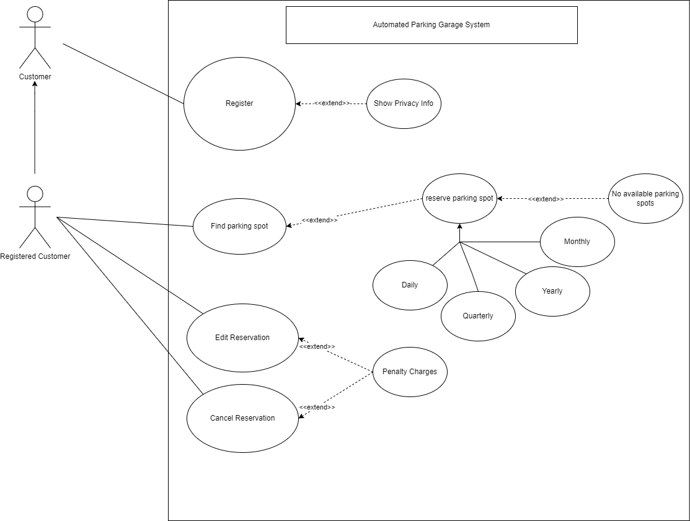

**4. Usage Scenario**

| **Description** | **Find parking spot** |
| --- | --- |
| **ID** | **B1** |
| **Author** | Yamen Aly |
| **Date** | **Thursday, May 25, 2023** |
| **Revised** | **Eng. Noha Sobhi** |
| **Actors** | **Registered Customer** |
| **Pre-conditions** | * **Customer’s info must be registered before, therefore they must be a registered customer.** |
| **Actions** | * **See if there are any available parking spots that are up for reservation.** |
| **Alternative actions** | * **If there are no available parking spots, then the customer should be informed.** |
| **Post-Conditions** | * **Reserve Parking Spot**   + **If a parking spot is available, customers could take part in a subscription to reserve this parking slot either daily, quarterly, yearly, or monthly.** * **No Available Parking Slots** |
| **Includes** |  |
| **Extends** | **Reserve Parking Spot** |
| **Generalizes** |  |

| **Description** | **Edit Reservation** |
| --- | --- |
| **ID** | **B2** |
| **Author** | Ahmed El Zokm |
| **Date** | **Thursday, May 25, 2023** |
| **Revised** | **Eng. Noha Sobhi** |
| **Actors** | **Registered Customer** |
| **Pre-conditions** | * **For the reservation to be edited, there must be an existing reservation in the first place** |
| **Actions** | * **Reservation could be edited, for instance, by changing the type of subscription the customer is already enrolled in. (e.g: from Yearly to daily, etc)** |
| **Alternative actions** |  |
| **Post-Conditions** | * **Penalty Charges**   + **If the customer modified his reservation after the grace period of 1 hour, a financial penalty is applied.** |
| **Includes** |  |
| **Extends** | **Penalty Charges** |
| **Generalizes** |  |

| **Description** | **Cancel Reservation** |
| --- | --- |
| **ID** | **B3** |
| **Author** | Mayar Hesham |
| **Date** | **Thursday, May 25, 2023,** |
| **Revised** | **Eng. Noha Sobhy** |
| **Actors** | **Registered customer**  **Bank** |
| **Pre-conditions** | * **For the reservation to be canceled, a reservation has to exist already.** |
| **Actions** | * **Reservation will be canceled upon the customer’s request.** |
| **Alternative actions** |  |
| **Post-Conditions** | * **Penalty Charges**   + **If the customer cancels his reservation after the grace period of 1 hour, the customer is charged with a penalty.** |
| **Includes** |  |
| **Extends** | **Penalty Charges** |
| **Generalizes** |  |

| **Description** | **Register** |
| --- | --- |
| **ID** | **B4** |
| **Author** | Mohamed Maghraby |
| **Date** | **Thursday 25/5/2023** |
| **Revised** | **Eng. Noha Sobhi** |
| **Actors** | **Customer** |
| **Pre-conditions** | * **Customer did not enter the parking garage as his car is not registered On the database of the system** |
| **Actions** | * **Enter the number on the car’s registration plate** * **Enter a picture of the driver's license** |
| **Alternative actions** | * **If the customer entered an invalid**   **number of the registration plate or a fake driver license He would be able to retry for 2 times if it is still not valid the customer will be blocked and will not enter**   * **If the customer is already registered on the system will show his information** |
| **Post-Conditions** | * **After the customer finishes reservation he will be able to view his privacy information** |
| **Includes** |  |
| **Extends** | * **Show privacy info** |
| **Generalizes** |  |

**5. Class Diagram**

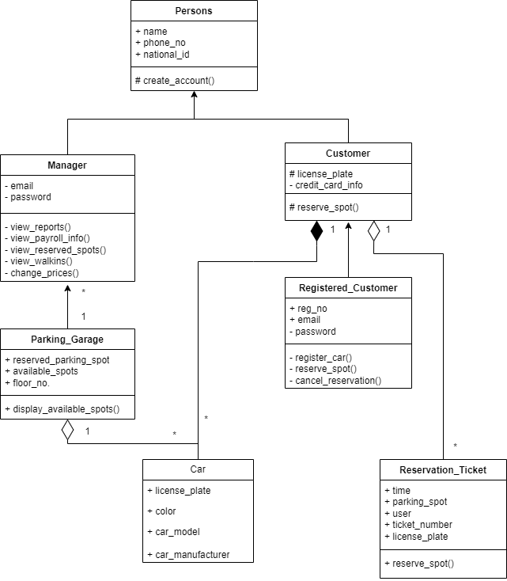

**6. Sequence Diagram**

**Yamen Aly**

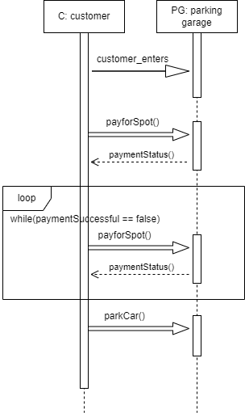

**Ahmed Elzokm**

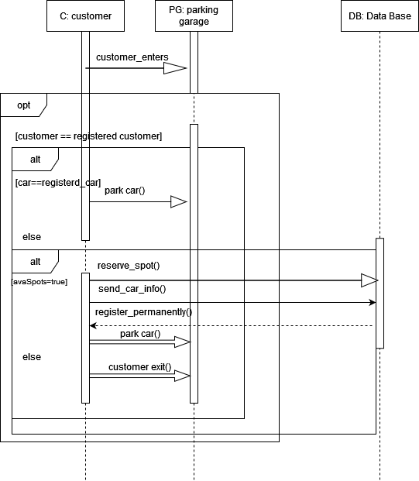

**Mayar Hesham**

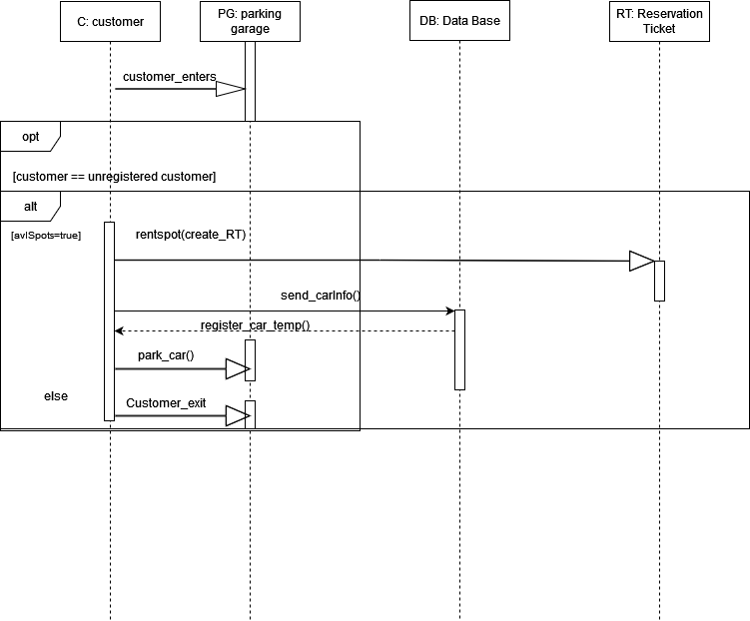

**Mohamed Maghraby**

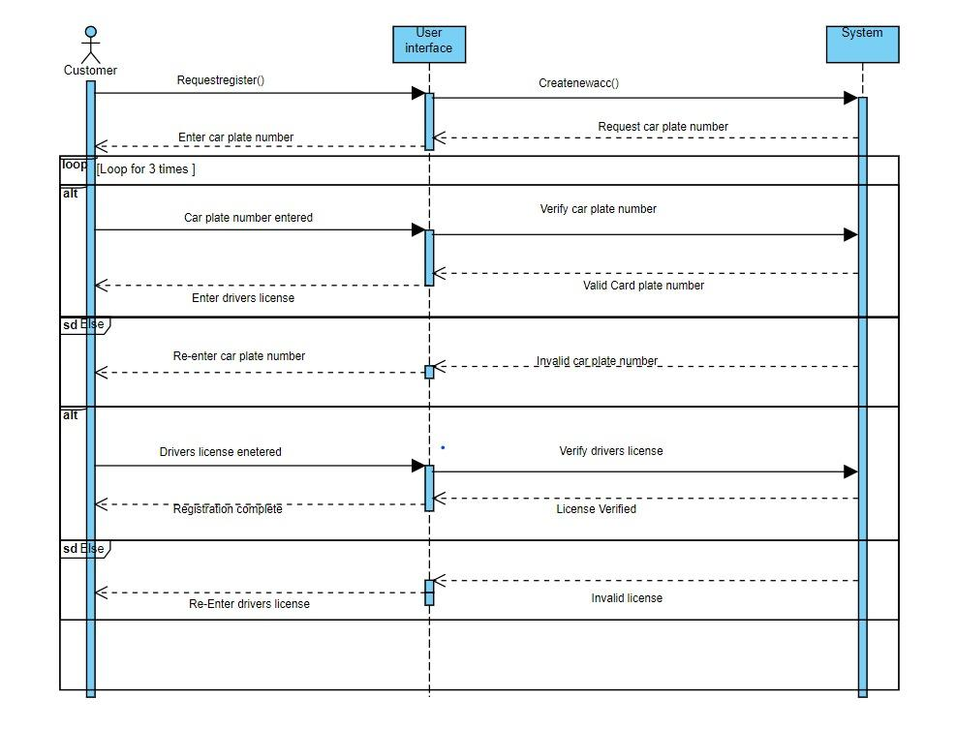

**7. State Chart**

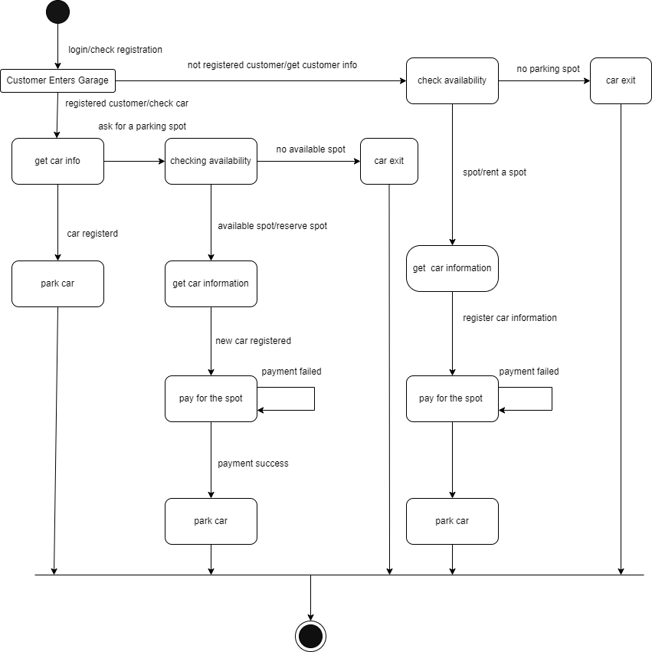

**8.Activity Diagram**

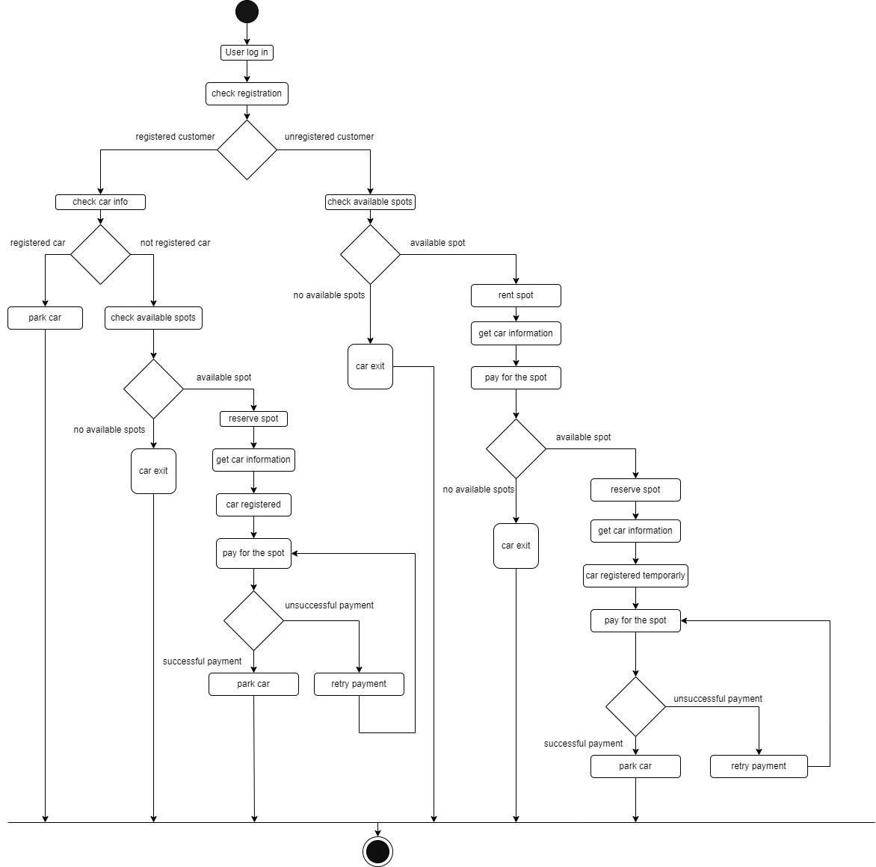

**9. ERD**

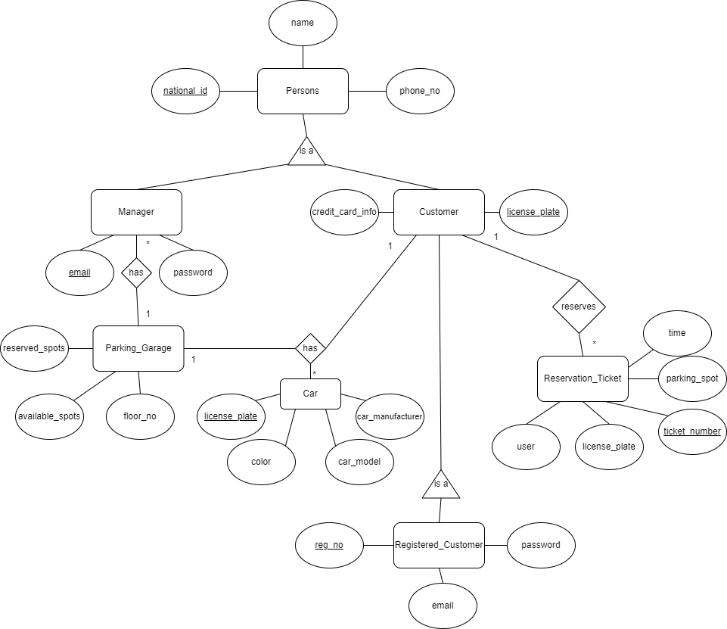

**10. Data Flow Diagram**

**10.1 Level 0**

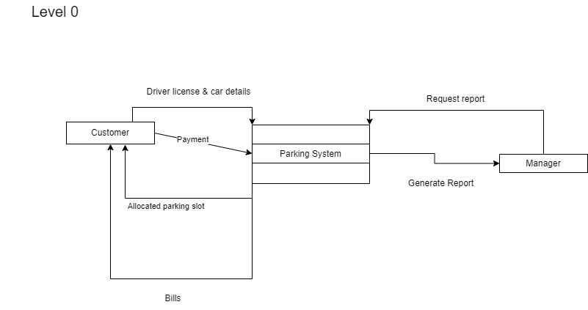

**10.2 Level 1**

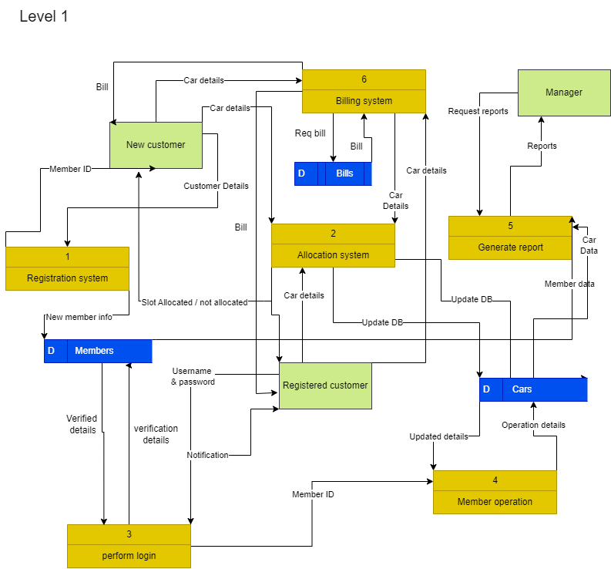

**10.3 Level 2**

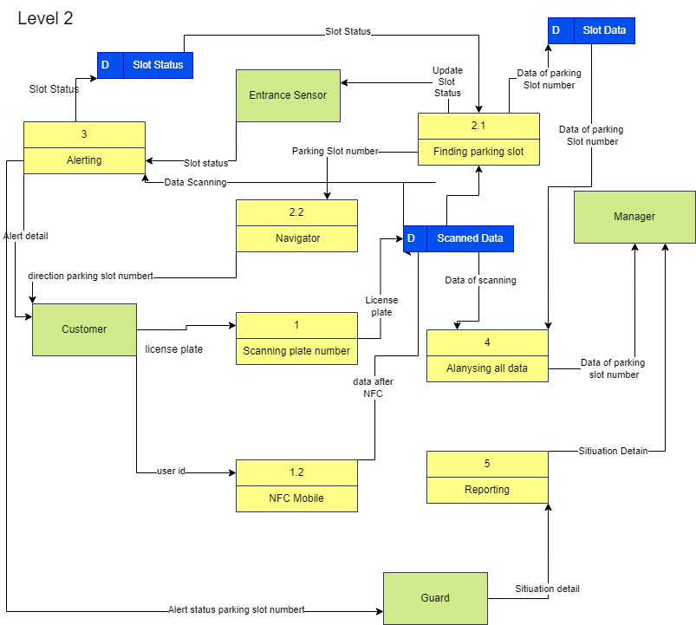

**11. Package Diagram**

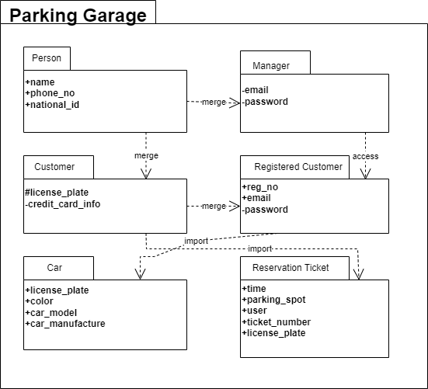

**12. Deployment Diagram**